Code Example 1: Signal procession
Code: week_6_example_1.py
Code description:
Step 1: signal filtering
A low-pass filter allows low-frequency components to pass through while attenuating high-frequency noise. This is useful for smoothing noisy signals, such as the noisy system measurements.
A common approach to implementing Low-Pass Filter is to use a first-order exponential moving average (EMA) filter or a Butterworth filter.
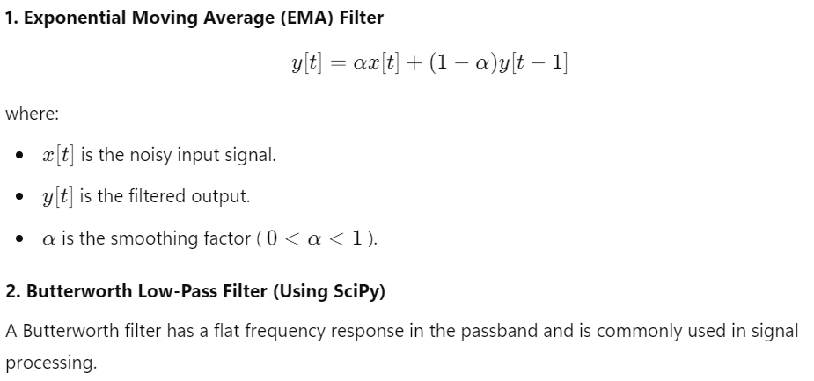
https://en.wikipedia.org/wiki/Exponential_smoothing
https://en.wikipedia.org/wiki/Butterworth_filter
Step 1: data normalization
https://en.wikipedia.org/wiki/Normalization_(statistics)

Code Example 2: System excitation
Code: week_6_example_2.py
Code description:
We compare the response of the dynamical system to a step signal and pseudo random binary sequence (PRBS) signal.
A step input can provide insights into settling time and steady-state behavior.
A PRBS input can be better for identifying the full dynamic behavior of the system.
System model:
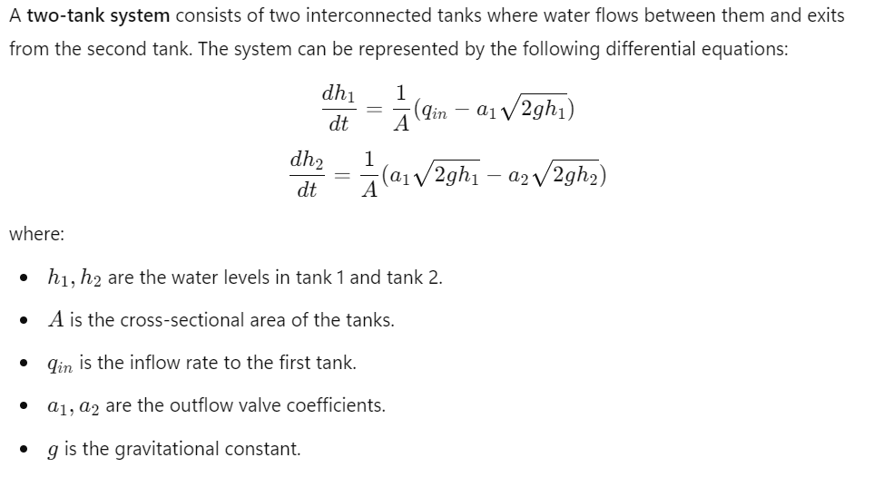

Code Example 3: auoregressive with exogenous input (ARX) model
Code: week_6_example_3.py
Code description: Code example with ARX model
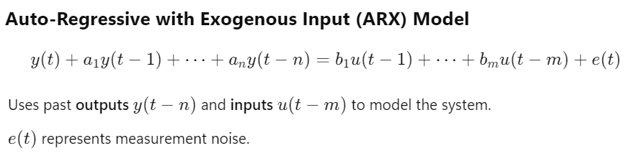

Code Example 4: Linear State-Space Model (LSSM) System ID
Code: week_6_example_4.py
Code description: the code uses least squares regression to A,B,C,D matrices in the linear state space model.
https://en.wikipedia.org/wiki/State-space_representation
https://en.wikipedia.org/wiki/Least_squares

Code Example 5: Neural State-Space Model (NSSM) System ID
Code: week_6_example_5.py
Code description:
A Neural State-Space Model (NSSM) is a data-driven approach to modeling dynamic systems using neural networks within a state-space representation. It is particularly useful for nonlinear system identification, control, and forecasting.
In this example we train simple NSSM to model dynamical system from time series input-output data. We will use Pytorch to implement this model.
